**Book Review and Search App**

**By Harshak krishnaa K (CB.EN.U4CSE17026)**

**Dependencies:**

* flask
* beautifulsoup4
* lxml

**Note**: Install all these dependencies by using `pip install <name>` this command in cmd/terminal/powershell.

**Steps to run:**

1. Open Terminal/cmd in the root directory of the folder
2. Execute the command `python app.py` after installing all the dependencies.
3. Press `CTRL + c` to stop the project

**Concepts Covered:**

* Flask:



* Cookies:





* Session:



* Error:

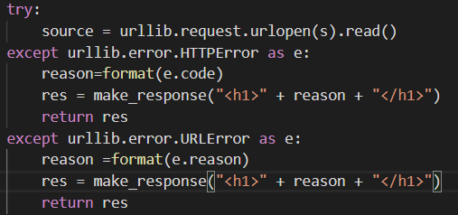

* BeautifulSoup:



* Urllib:



UI Screenshots: 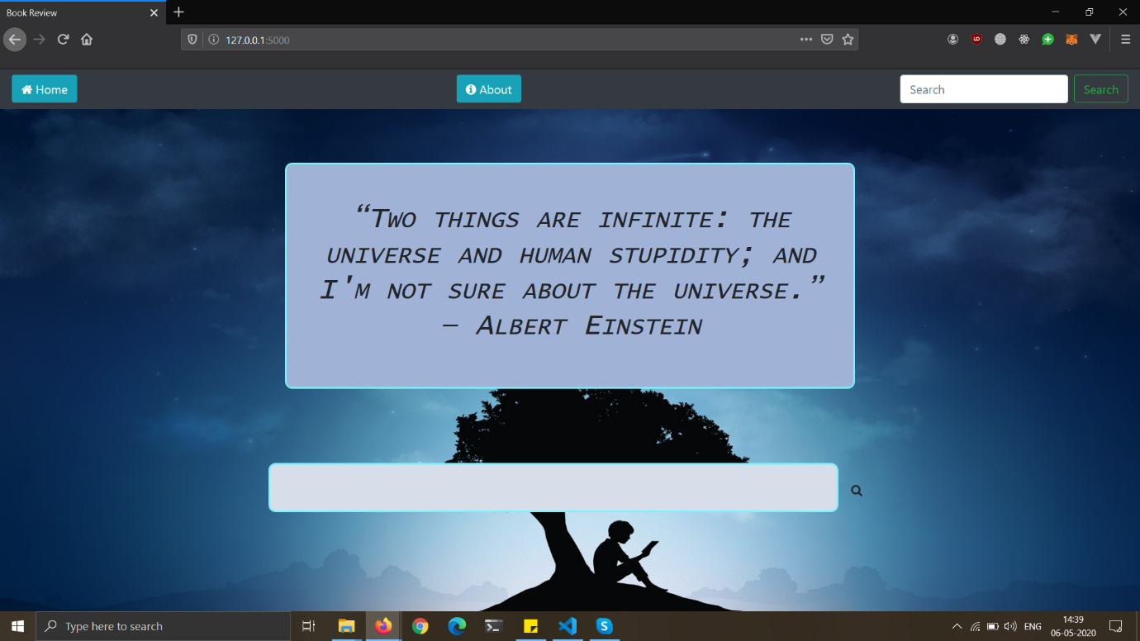

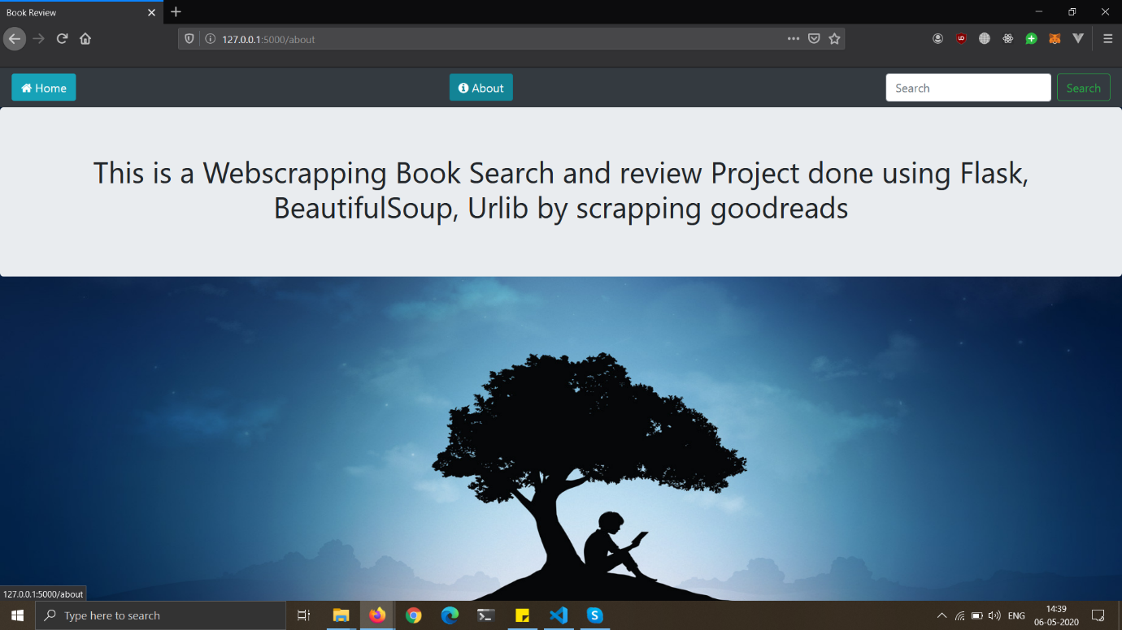

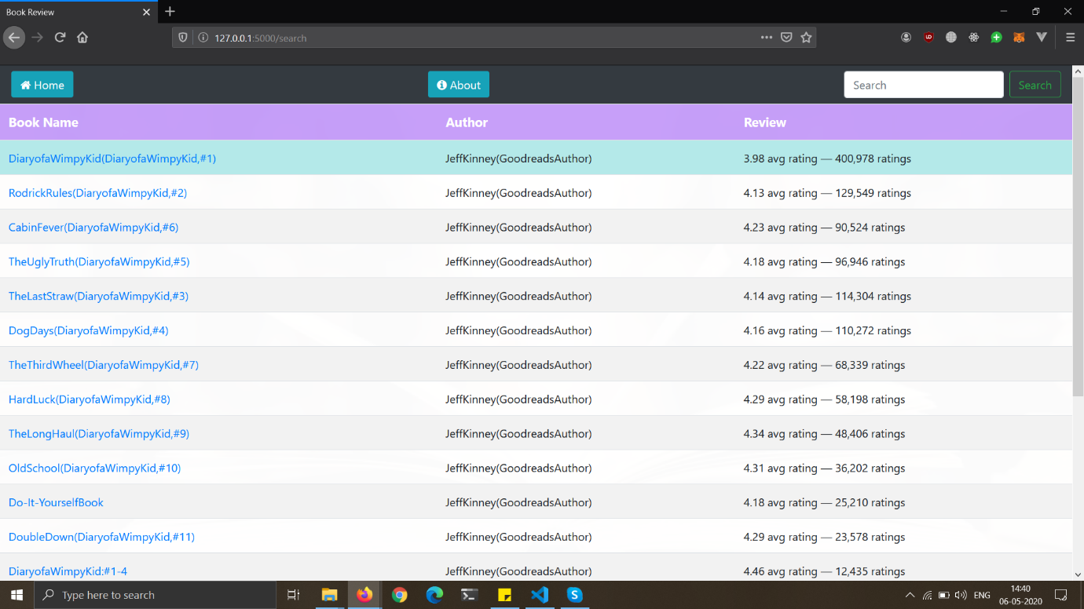

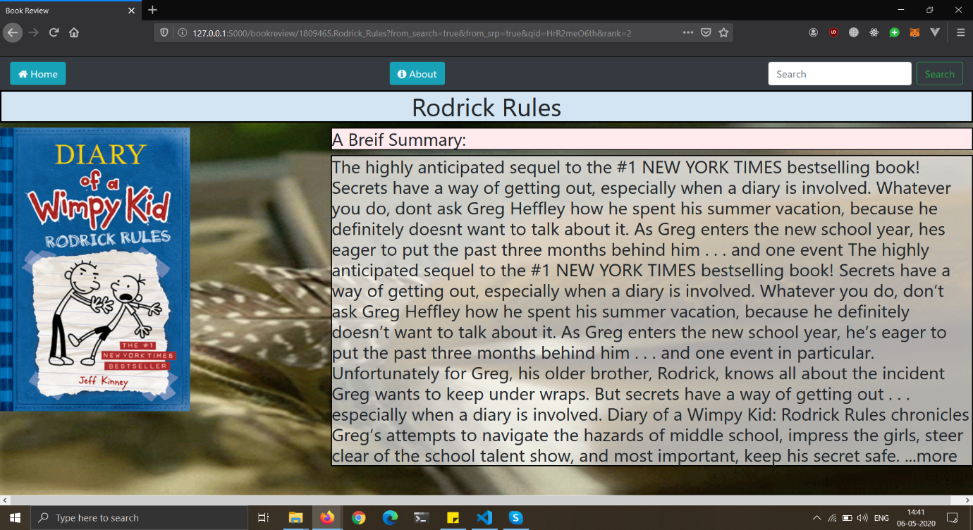

**Video Demo of the Webapp:**

<https://youtu.be/bAQ8AN_4mJE>

**\*\*\*Thank You\*\*\***